Capital Project Highlights 2016/2017
____________________________________________________________________________________________________________

Green Gryphon Initiative
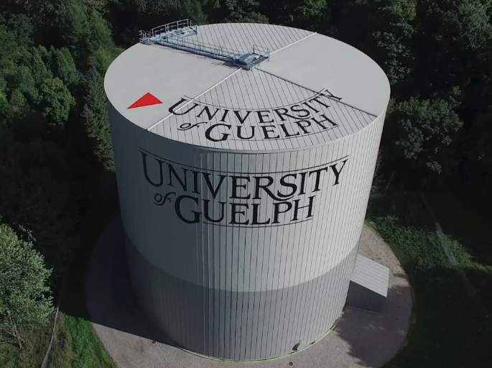
A 26 million dollar energy project, dubbed the Green Gryphon Initiative (G.G.I.), was completed in 2016/2017. The highlight of this project was a thermal energy storage system that received a 5 million dollar government incentive. The project also received 3.5 million dollars in funding from the Student Energy Retrofit Fund. The yearly operating budget savings for the G.G.I. is over 2.5 million dollars.

Mitchell Centre Expansion
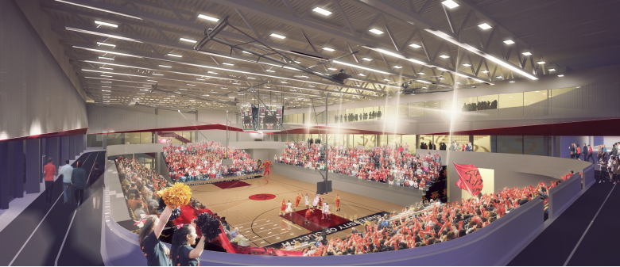
The 45 million dollar Mitchell Centre Expansion was completed in 2016/2017. This 160,000 square foot addition to our athletic facilities doubles the size of the 1958 Mitchell Centre which was built to serve half as many students as we now have. The expansion is an important part of student and staff wellness priorities.

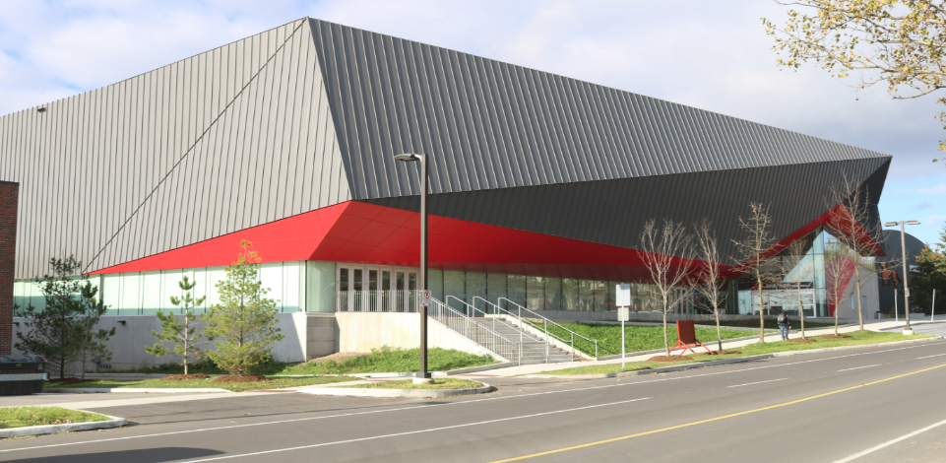

Repurposing of Macdonald Hall
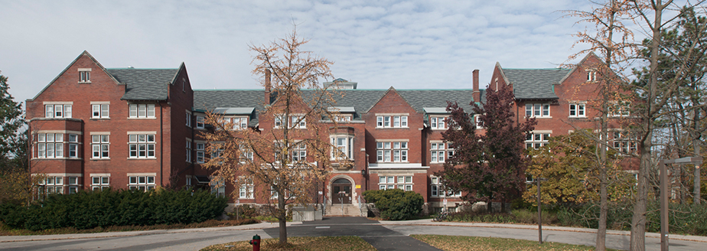
The 12 million dollar Repurposing of Macdonald Hall for the College of Business and Economics (C.B.E.) was completed in 2016/2017. Macdonald Hall, which was constructed in 1903, was in dire need of renewal and C.B.E. was growing and in need of consolidation under one roof. Prior to the renovation, Macdonald Hall was utilized as student residence facility.
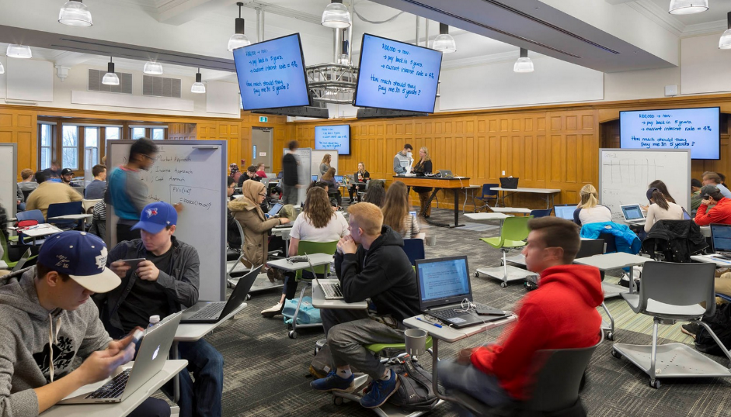

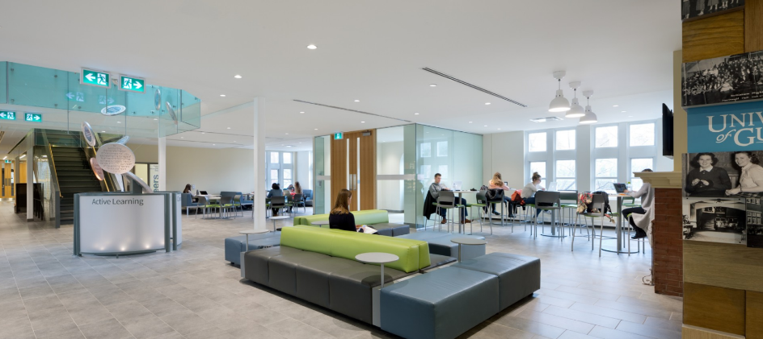

Alumni Football Stadium
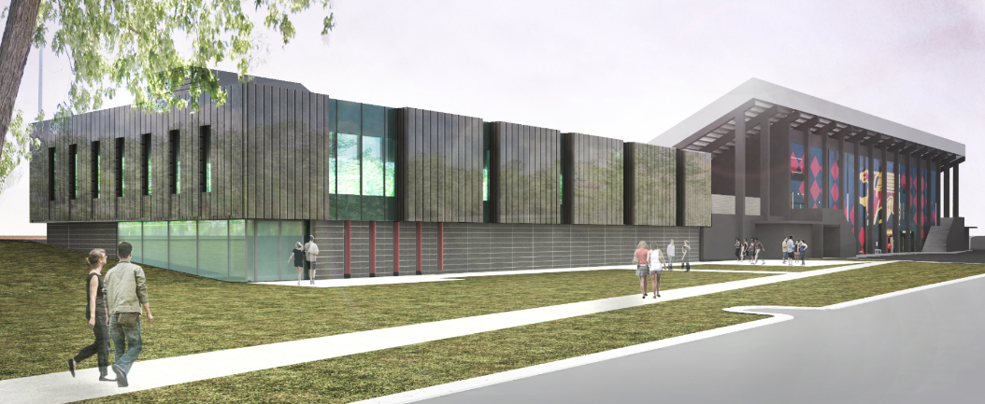

The 10 million dollar Alumni Stadium Football Pavilion was completed in 2016/2017. The landscaping and road improvements to enhance this project will be completed in the summer of 2018. With the new track, new football pavilion and renovations to the existing facilities, our Stadium Precinct has become a marvelous corner of the campus serving the University and the greater Guelph community. The funding for this project was 100% from a donor, Stu Lang. Powerhouse Lane was renamed Lang Way to honour this generous donation.

University Centre Renovations
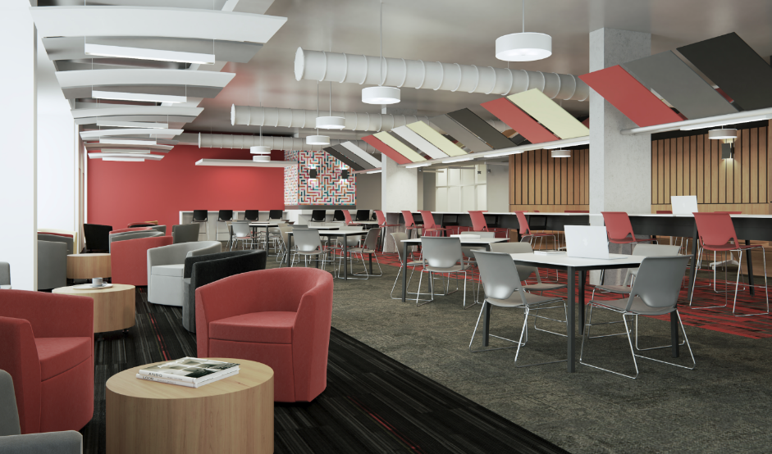
A 3 million dollar renovation at the south end of the University Centre was completed in 2016/2017. This project included some much needed infrastructure renewal and the creation of new and exciting student study and club spaces on the first and second floors at this end of the building.

Renovation and Renewal of the Library Lower Level
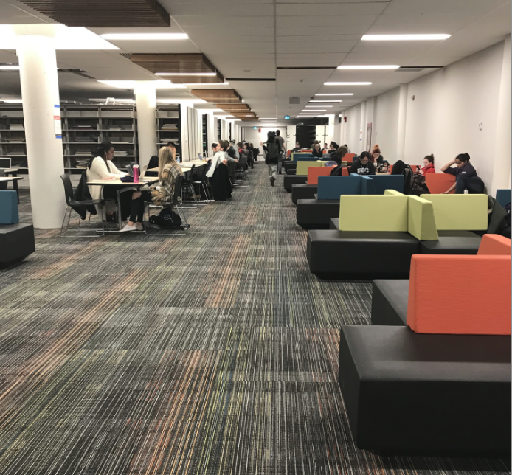

In 2016/2017 work neared completion on the 5 million dollar Renovation and Renewal of the Library Lower Level. This project created compact solutions for archives and collections and freed up much needed space for student study and collaboration. It also renewed infrastructure first constructed in 1968

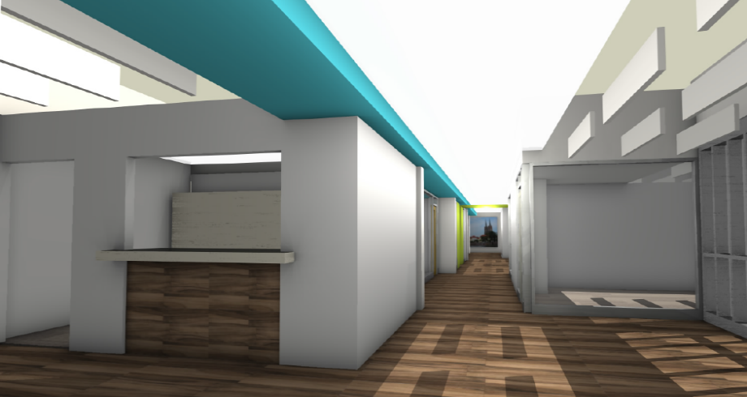

Relocation of the Turfgrass Institute
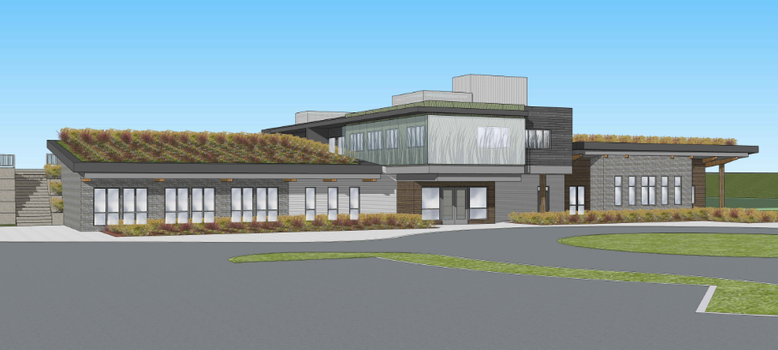
Work commenced in 2016/17 on the 15 million dollar relocation of the Turfgrass Institute from its Victoria Street. location to the Arboretum. The biggest challenge for this project was to blend in with the delicate ecosystems of the Arboretum and meet City of Guelph environmental requirements. Construction will be complete in spring of 2019.
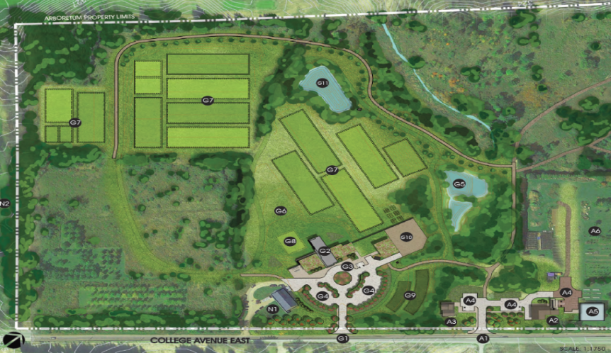

Strategic Infrastructure Fund (SIF) Projects
The University commenced work on the 66 million dollar Strategic Infrastructure Fund (S.I.F.) projects in 2016/2017. There are six projects in total, three renovation/renewals and three additions, which are required to be complete in spring 2018. The focus of these projects is research facilities and enhancing our reputation as a top research institution.

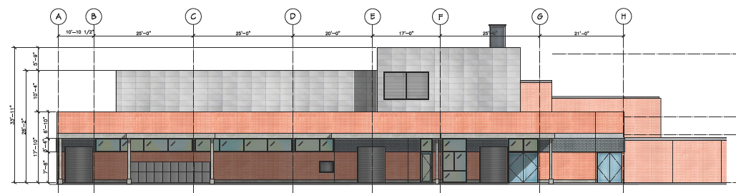
Production Animal Research Isolation Unit.

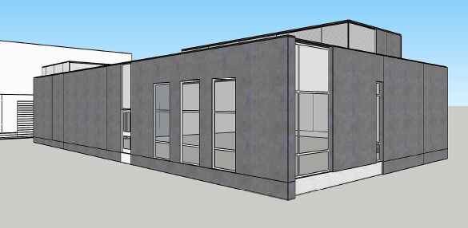

Bioproducts Discovery and Development Centre: Bio-carbon Research Centre.
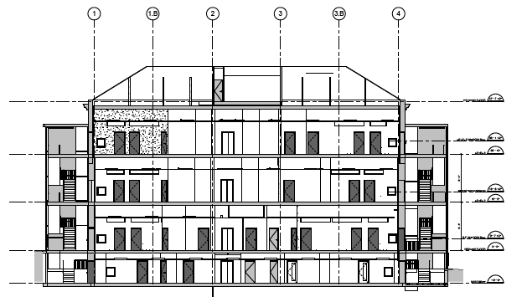
Research and Collaborative Space for Computer Science and Engineering Students and Faculty.

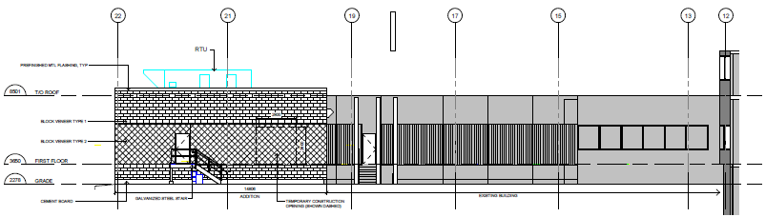
Food Innovation Centre

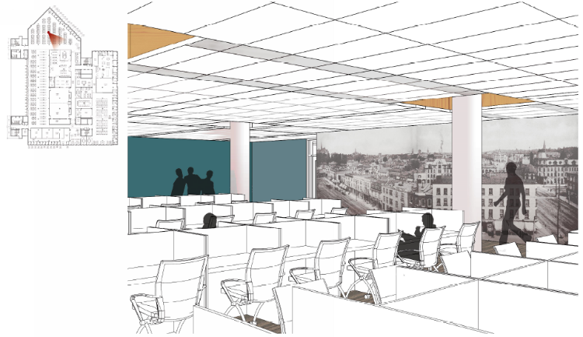
Research Collaboratory: McLaughlin Library Renewal and Renovation Diagram 1.

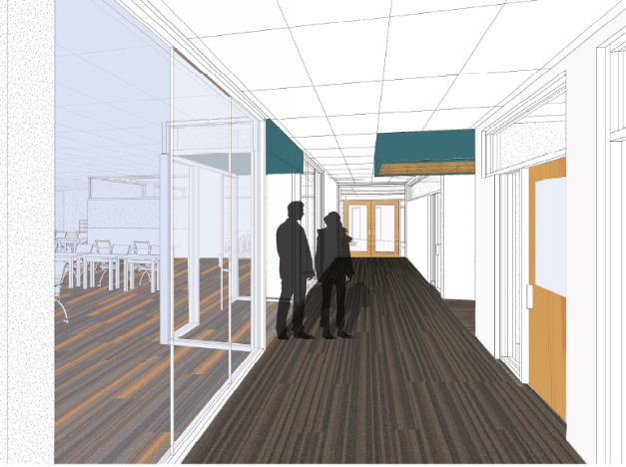
Research Collaboratory: McLaughlin Library Renewal and Renovation Diagram 2.

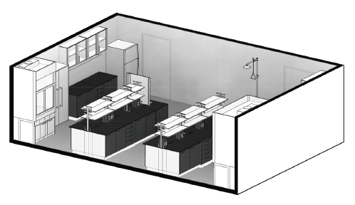
Renewal and Renovation of the MacNaughton Building.
Other projects that commenced in 2016/2017 included:
- O.V.C. Phase 1 – a 15 million dollar renovation of the veterinary hospital.
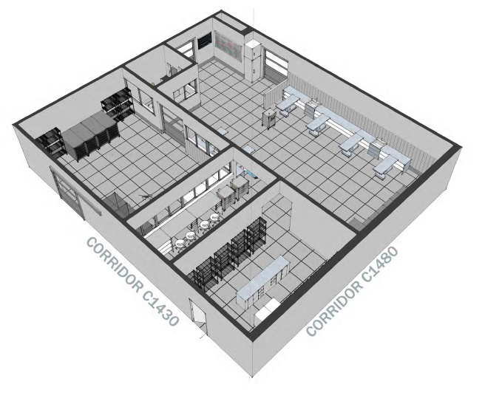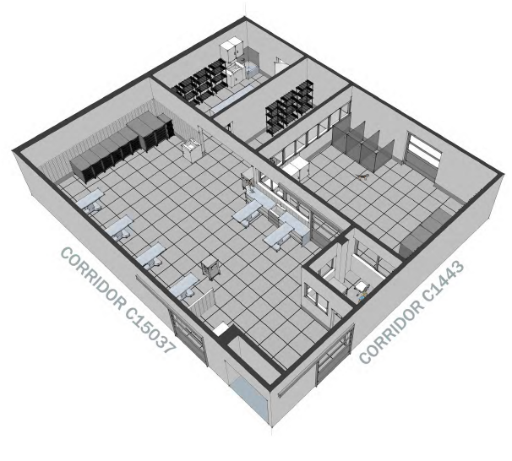
- O.V.C. Phase 2 - a 20 million dollar “Enhanced Learning” addition.
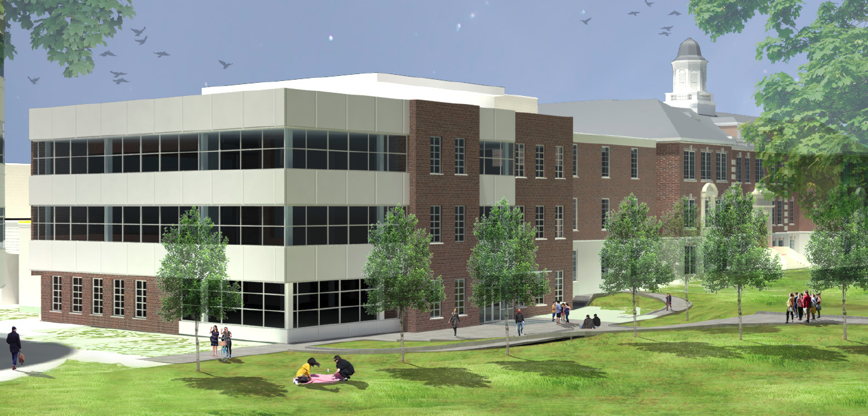

- J.T. Powell Renovation and Addition – a 12 million dollar project to create a central consolidated student wellness hub for the campus.
